Introduction

# The preamble

This introduction is designed to provide some context for DHIS2 administrators who have been asked to utilise HIV estimates in DHIS2. An HIV-Spectrum Bootstrap Application (App) has been built to facilitate this process and if used will initialise a set of standard pre-packaged indicator and analytical elements that draw on the HIV estimates and other programme data in DHIS2.

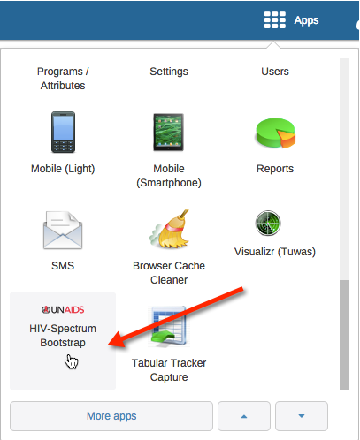

Figure 1: Screen capture of the DHIS2 HIV-Spectrum Bootstrap App Icon

Several support guides are available as part of the App, and include:

1. An App administrative guide;[1]
2. A post-initiation guide for further configuration of the pre-packaged HIV estimate data elements and indicators once they have been initialised; [2] and
3. Guidance on how to prepare and import Spectrum extracts.[3]

# A word of caution

The configuration and administration of DHIS2 is a specialist topic that involves significant prior knowledge. The use of the App and the associated guidelines is intended for DHIS2 administrators who are already familiar with:

* Setting up permissions and utilization of DHIS2 Apps.
* The configuration and use of DHIS2 Data Elements, Indicators and Dashboards; and
* The loading and use of DHIS2 Documentation.

# Setting the context

This app facilitates use of HIV estimates within DHIS2,[4] an open source analytics platform used widely by Ministries of Health in Low and Middle Income Countries (LMIC). Access to these estimates would enable Ministries of Health and other interested parties to combine them with local programme data already collected in DHIS2 to generate useful HIV/AIDS indicators, and leverage the visual analytics capabilities of DHIS2.

While the creation of indicators is a uniquely localised process in DHIS2, the fact that HIV estimates are standardised provides an opportunity to partially automate the setup these estimates as objects in DHIS2.

The App provides a relatively easy way to take advantage of HIV estimates by:

* Instantiating standard Spectrum HIV/AIDS data elements;
* Instantiating a set of placeholder Indicators that use the Spectrum HIV/AIDS data elements;
* Providing access to relevant support documentation from within the DHIS2 platform to guide the DHIS2 Administrator in further customisation of the data elements and indicators.

It should be noted that the UIDs of the data elements and indicators instantiated by the Bootstrapping App will be common to all DHIS2 instances where it has been run. This provides opportunities in the future to leverage these indicators due to them being standardised and identifiable objects within any DHIS2 instance.

# The resulting data elements and indicators

The HIV estimates consist of a number of ‘data elements’ that are disaggregated by standardised age-brackets, gender, and sub-national geographic breakdowns. To support the widest possible import potential, the ‘data elements’ initialised as a result of running the App are handled as separate objects rather than as a single equivalent data element.

Examples of the HIV data elements instantiated in DHIS2 by the App include:

* HIV Den: Estimated number of HIV+ pregnant women
* HIV Den: Estimated number of people (15+) eligible for ART according to national guidelines
* HIV Den: Estimated number of people (<15) eligible for ART according to national guidelines
* HIV Den: Estimated number of people (15+) living with HIV
* HIV Den: Estimated number of people (15-49) living with HIV
* HIV Den: Estimated number of people (<15) living with HIV

The indicators that are also initialised as a result of running the App utilise the above data elements as denominators:

* HIV Ind: Percentage of all people (15+) living with HIV who are receiving ART
* HIV Ind: Percentage of all people (<15) living with HIV who are receiving ART
* HIV Ind: Percentage of HIV+ pregnant women who receive antiretrovirals to reduce the risk of MTCT
* HIV Ind: Percentage of HIV-exposed infants who received an HIV test
* HIV Ind: Percentage of people (15+) eligible for HIV treatment according to national criteria that are receiving ART
* HIV Ind: Percentage of people (15+) living with HIV who are enrolled in HIV care
* HIV Ind: Percentage of people (15-49) living with HIV who are enrolled in HIV care
* HIV Ind: Percentage of people (<15) eligible for HIV treatment according to national criteria that are receiving ART
* HIV Ind: Percentage of people (<15) living with HIV who are enrolled in HIV care

Local Programme data already defined in the DHIS2 instance will be used as numerators for the indicators. Placeholder numerator data elements with the prefix *(replace)* are also instantiated when the App is run, and include:

* (replace): Number of people (15+) enrolled in HIV care
* (replace): Number of people (15+) receiving ART
* (replace): Number of people (15-49) enrolled in HIV care
* (replace): Number of people (15-49) receiving ART
* (replace): Number of people (<15) enrolled in HIV care
* (replace): Number of people (<15) receiving ART
* (replace): Number of women receiving antiretrovirals to reduce the risk of MTCT
* (replace): Total HIV-exposed infants testing by 12 months

1. The guideline “UNAIDS_SPECTRUM_DHIS2_Bootstrapping_App_Admin_Guide_V0x_EN.pdf”
2. The guideline “UNAIDS_DHIS2_Spectrum_Bootstrap_PostInitiation_Guide_V0x_EN.pdf”
3. The guideline “UNAIDS_SPECTRUM_DHIS2_RawData_Preparation_Guide_V0x_EN.pdf”
4. See <https://www.dhis2.org/>